**Memo**

**Senior Design**

ENG EC 463

To: Professor Pisano, Professor Alshaykh

From: Michael Ethier, Solomon Utain, Ami Vyas, Alexander Wang

Team: Team 3

Date:

Subject: First Deliverable Test Report

**1.0 Project Objective**

1.1 The overall goal of this breast cancer probe project is to develop a miniature DOS probe capable of measuring metabolic changes in fatty tissue over time. This data would give insight into the effectiveness of various chemotherapy treatments in individual cases of breast cancer.

**2.0 Test Objective and Significance**

2.1 The objective of this test is to make sure that our circuit board with the 4-wavelength VCSEL works properly with the benchtop system and can properly output light at the four desired wavelengths, and these can be detected and measured by the Avalanche Photodiode (APD).

2.2 The significance of this testing is that the VCSEL board will be able to be used to conduct measurements of optical properties of silicone phantoms, and that it can be used in tangent with the APD to examine the properties of the current detector evaluation circuit board so the evaluation board may be readjusted and redesigned.

**3.0 Equipment and Setup**

3.1 PCB Testing

In this test, the wavelengths of light output by the VCSEL were tested. The VCSEL was placed in the PCB and powered using a current source connected to an RF switch. The output of the VCSEL was fiber coupled to a spectrometer. This was controlled with the computer software AvaSoft, which ran and graphed frequency sweeps that would pick up the intensity of light being detected in the optical cable.

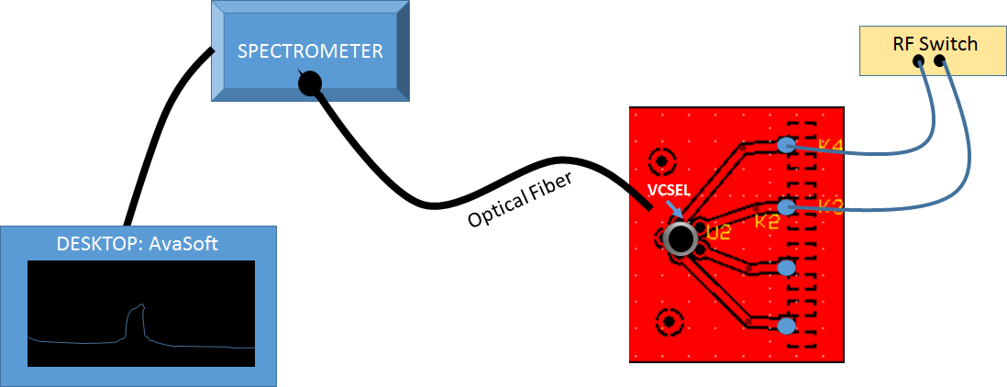

Figure 1: VCSEL PCB Spectrometer test connections

The parameters for running the test on each pin/wavelength of the VCSEL are listed in the table below. The four different pins require different current levels and have different intensities of signals, so they must each be controlled individually.

**Table 1: VCSEL Testing Parameters**

|  |  |  |  |
| --- | --- | --- | --- |
| **Pin Number** | **Wavelength** | **Current** | **Integration Time** |
| **1** | 660 nm | 10 mA | 2 ms |
| **2** | 680 nm | 15 mA | 2 ms |
| **3** | 775 nm | 5 mA | 10 ms |
| **4** | 795 nm | 10 mA | 2 ms |
| **5** | Ground | N/A | N/A |

Graphs of the wavelength sweep versus intensity of the signal were produced for each pin. The peaks of the graphs were shown to be at the wavelengths the VCSEL was expected to be outputting.

3.2 APD Measurements

In this test, the VCSEL output light into a phantom which was scattered or absorbed and ultimately measured by an Avalanche Photodiode in an evaluation board provided by Hamamastu.

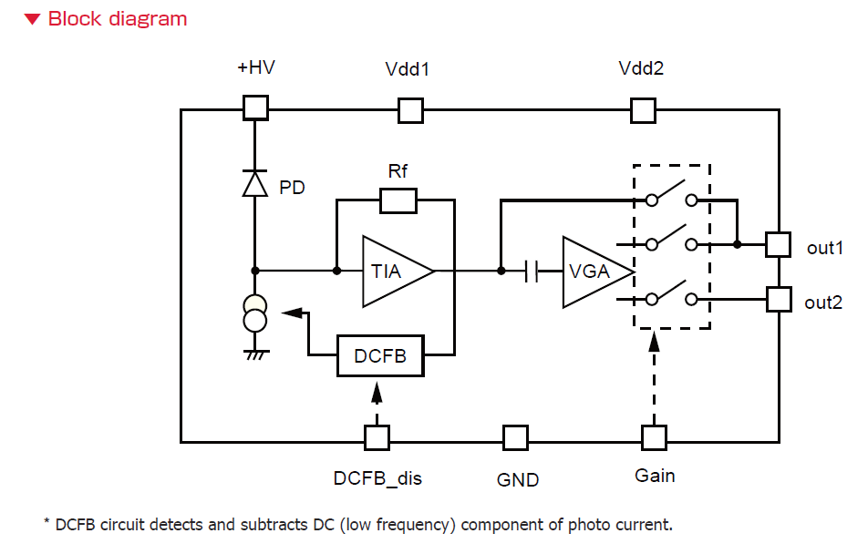

Figure 2: Evaluation board circuit diagram

The switches on the board were tested for optimal signal-to-noise ratio. These correspond with the table below. For the first test, we used the worst signal-to-noise ratio. This was Low Gain, DCFB off. For the second test, we used what we had previously found to be the best signal-to-noise ratio. This was Low Gain, DCFB on.

**Table 2: Switch Settings**

|  |  |
| --- | --- |
| **Switch 1** | **Switch 2** |
| 1 – High Gain | 1 – DCFB off |
| 2 – Low Gain | 2 – DCFB on |

One of the four lasers were used to conduct the tests (775nm). The electrical connections from the last test were retained, and some additional connections were made to power the evaluation board and APD and read the detector signal. The VCSEL was placed flush against a phantom so that its light passed through a phantom and into an optical cable which fed into the detector. In noise floor measurements (taken for each switch configuration), the phantom was covered with a black rubber slab so that the light from the VCSEL would not travel to the detector. The source-detector separation (distance between VCSEL and optical cable on phantom) was measured to be 8.5 mm. The signal from the evaluation board was read by a network analyzer and reports of the measurements were generated in LabView. This data was opened in Microsoft Excel to create the graphs for the results.

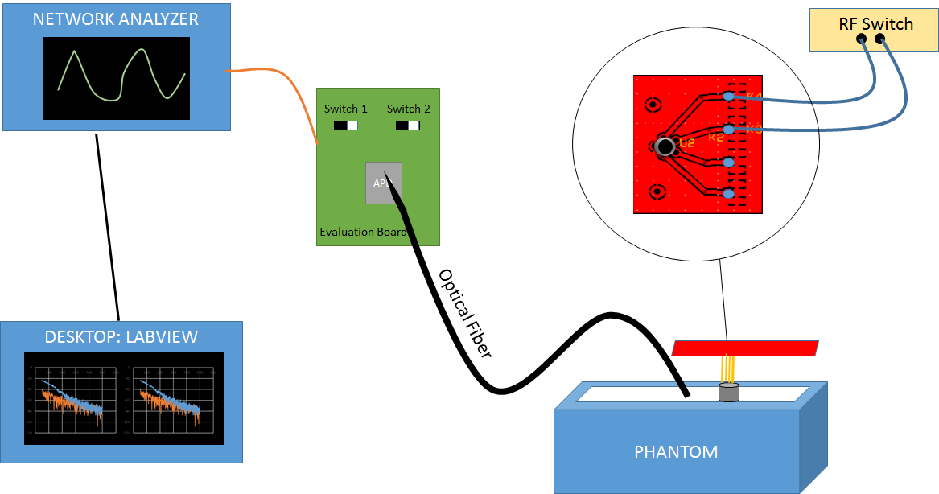

Figure 3: Source-detector test connections

**4.0 Measurements and Data**

4.1 Spectrometer Results

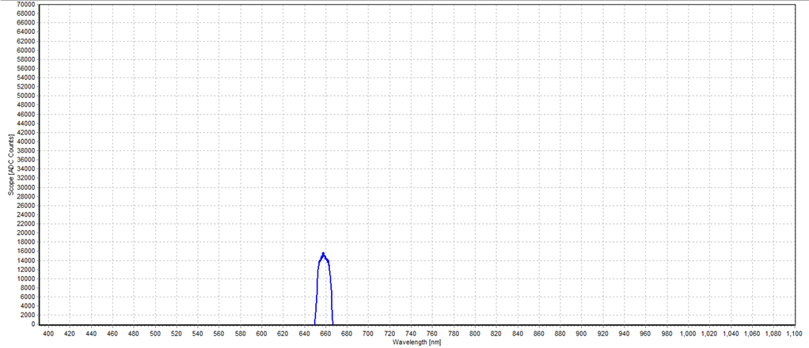

Figure 4: Pin 1 (660nm) test

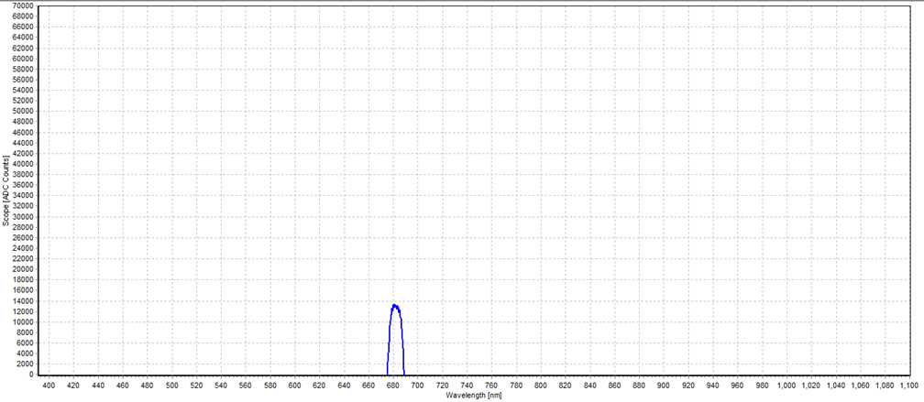

Figure 5: Pin 2 (680nm) test

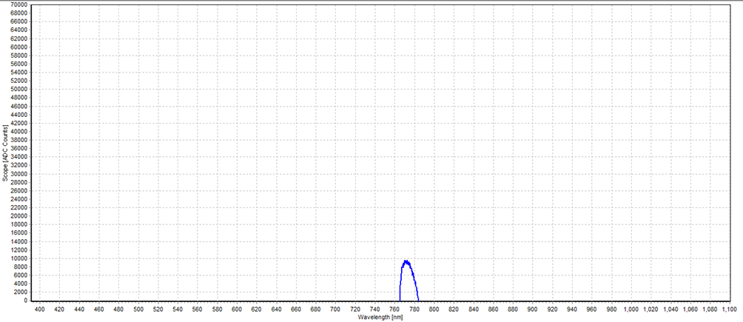

Figure 6: Pin 3 (775 nm) test

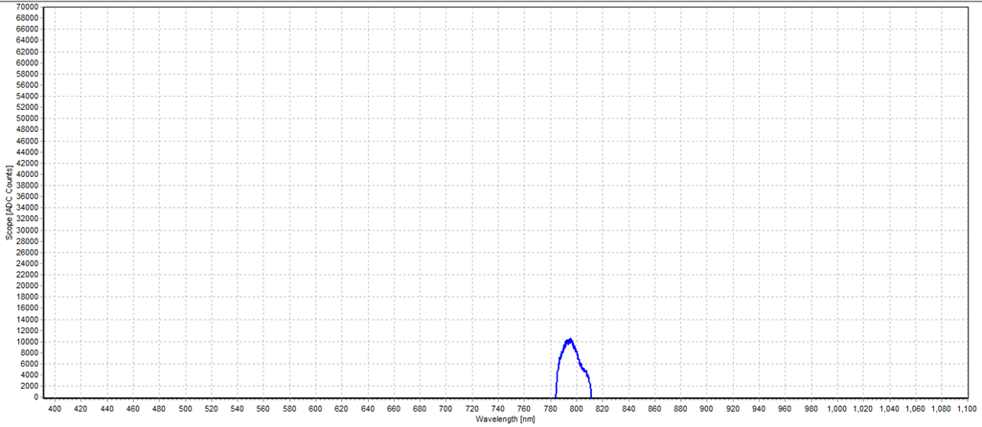

Figure 7: Pin 4 (795nm) test

In each figure, there is a peak in intensity at different wavelengths. These peaks occur at about 660 nm for laser 1, 680 nm for laser 2, 775 nm for laser 3, and 795 nm for laser 4.

4.2 APD Testing Results

For the first test, the switches on the APD were set to Low Gain and DCFB off. DCFB is background correction. The graph below is the output of the testing shown in Labview and recreated in Microsoft Excel.

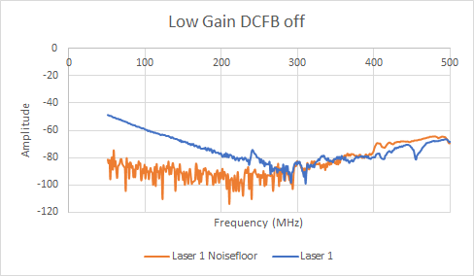

For the second test, the switches on the APD were set to Low Gain and DCFB on or background correction on. The graph below is the output of the testing shown in Labview and recreated in Microsoft Excel.

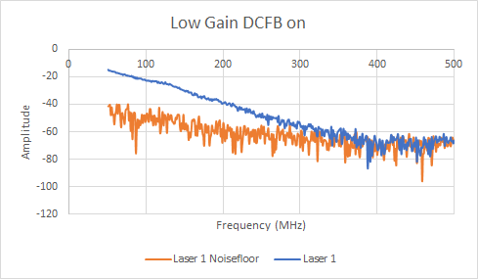

**5.0 Conclusions**

5.1 Spectrometer Results Analysis

Each figure had a clear peak at one specific wavelength. For laser 1, it occurred at 660 nm. For laser 2, it occurred at 680 nm. For laser 3, it occurred at 775 nm, and for laser 4 it occurred at 795 nm. This indicates that the VCSEL board was indeed able to output a consistent laser at 660 nm, 680 nm, 775 nm, and 795 nm respectively.

5.2 APD Testing Results Analysis

The graphs produced by these tests were consistent with the graphs produced by testing our client’s previous three wavelength VCSEL setup. As expected, the test with DCFB (background correction) off had much more noise than the test with background correction on. The noise floor for both of the tests should be below the laser signal and this was generally true except for at higher frequencies. This is most likely due to the fact that an optical fiber was used to send the light coming out of the phantom to the APD. This isn’t ideal because optical fibers do introduce some noise but it had to be used because the current APD prototype board cannot be placed flush onto the phantom.